Chapter 7, Problem 58.

Rework Prob. 7.17 if i(0) = 10 A and v(t) = 20 u(t) V.

Chapter 7, Problem 17.

Consider the circuit of Fig. 7.95. Find v₀(t) if i(0) = 2 A and v(t) = 0.

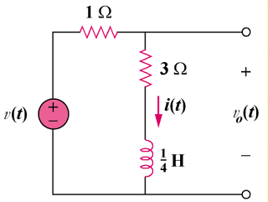

Figure 7.95
For Prob. 7.58.

